**Prediction of Material Removal Rate (MRR) in Chemical Mechanical Polishing Process**

**Goal:**  To predict polishing removal rate of material from a wafer using:

1. Multiple Regression (with Gradient Descent)

2. Support Vector Regression (with Gradient Descent, and sklearn.svm module)

**Data Description**: Data collected production lines with two MRR ranges provided:

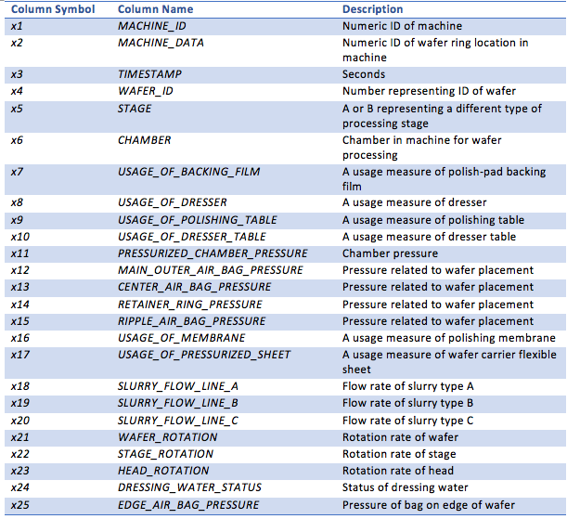

**Hint:**

1. Normalize the sensing data
2. Try different combinations of sensing variables as prediction variables. Specifically in this study, the condition of the polishing pad and dresser change over time as they are being used. These states affect greatly the MRR.
3. Build separate prediction models for different MRR ranges.

**Requirement:** A data analytics report together with the original codes should be submitted to Canvas by **2/21**. Following elements should be included in the report:

1. Which combinations of sensing variables have you tried? Why? What are the findings?
2. Performance comparison among multiple regression, support vector regression (SVR) through gradient descent, and support vector regression through sklearn library. The performance of models should be evaluated in R2 and root mean square error (RMSE).
3. Any other trials (e.g. different parameters in SVR) and findings, any difficulties/learnt knowledge points in coding.